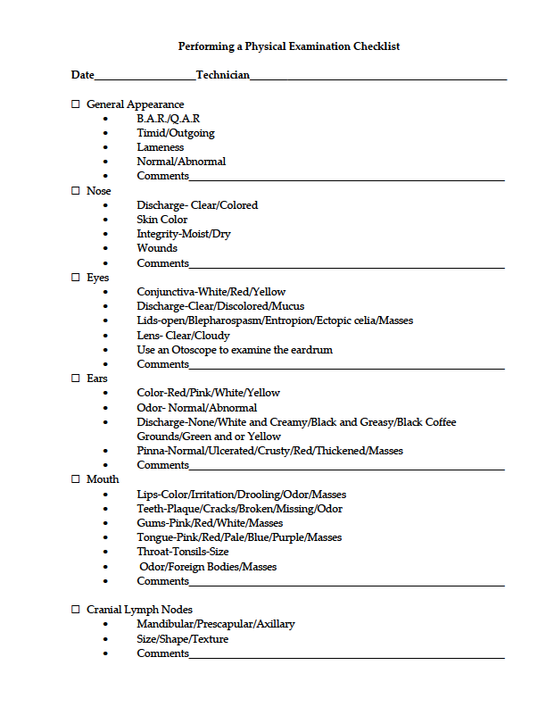**Performing a Physical Examination Checklist**

**Date___________________Technician________________________________________________**